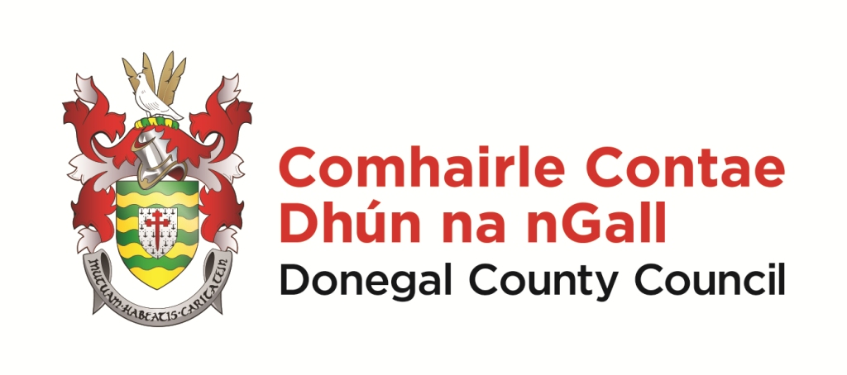
Development Fund Initiative 2024 – Application Form.

- Contact Details.
Name of Applicant/Group/Organisation:
(Group Name and Name on Bank Account Statement must correspond).
Contact Person for correspondence:
Address for contact person:
Phone number for contact:
Contact email:
Name of Treasurer:
Treasurer/Group email:
Treasurer phone number:

2. Tax Details.
Organisation’s tax/charity reference number and name:

Is the organisation registered for VAT? ________________ VAT Ref:__________________

3. Municipal District(s).
Insert ‘Yes’ under the Municipal District(s) you wish your project to be considered by:
Glenties | Donegal | Inishowen | Letterkenny | Stranorlar

4. Project Description (refer to the background, research undertaken, need identified, location of the project, facilities/services/activities, expected outcome and potential benefits etc.).

5. DFI Funding Total Sought (note: the minimum allocation under DFI is €2,500).
Total amount of funding being sought from the DFI: €
Estimated total cost of the project: €

6. Project Cost :
Breakdown of estimated total costs:
Item | Amount (€)
1.
2.
3.
4.
5.
6.
Total:

7. Other Funding Sources (if applicable).
No | Funding Source | Details | Applied For (€) | Approved (€)
1.
2.
3.
4.

8. Committee/Board - Names/Positions.
Name/Position | Name/Position | Name/Position

9. Project Timelines/Permissions (do not submit evidence with the application form).
Estimated Start Date: Estimated End Date:

If applicable, do you have ownership/a satisfactory lease in place?
If applicable, has planning permission been granted?
If applicable, are all other licences/permissions in place?

Completed application form submitted by:

Name: Position: Date:

10. Submitting an application.

Completed forms can be submitted using one of the following methods only:
1. Email to: dfi@donegalcoco.ie
2. Post to: Development Fund Initiative, Community Development Division, Donegal County Council, Station Island, Lifford, Co. Donegal.

An email acknowledging receipt of the application will be issued. If you do not receive an email acknowledgement phone 087 1141094 or 074 9172341
Closing time/date: 4pm on Friday 2nd February 2024.

IMPORTANT:
Applications received after this time/date will be deemed ineligible. For further information contact Ann Marie Collum by email dfi@donegalcoco.ie or phone 074 9172341/ 087 1141094.

